


Project Navodaya

ABAP Technical Specification

Document Information

Document Number
Title | RAP Application for Lost Time Injuries
Document Purpose | Graphical representation for Lost Time Injuries
Key Words
Document Status | Final
Contact for Enquiries | Arnav

Document Change Control :
Release | Description | Created by | Date | Reviewed by | Date | Approved by | Date
01 | RAP Application for Lost Time Injuries | Arnav | 09-12-2025

Header
Area (R/3Module): | EHS |  |  |  |  | Date: |  | 09-12-2025
Requested by: | GAIL EHS Team
Title: | RAP Application for Lost Time Injury Report
Short description: | Graphical representation for Lost Time Injury Report
Functional Developer: | Sunil Jawalkar (SAP) |  |  |  |  |  | Phone: | +91
Technical Developer: | Arnav Johri |  |  |  |  |  | Phone: | +91 9971324400
Program name:
Type: | Change Request Development Request(Creation) Rework
Program type: (select the check box) | Conversion Batch Interface Online Interface Report  Form Enhancement Extension Dialog  Modification Unknown Others BAPI  ALE/ IDOC Application Development
Priority: | Very High High Medium Low
Complexity: | Very High High Medium Low
Specify known SAP functionality: |  | <Specify the related SAP transactions>
Cross Reference Documentation:
Only for Interfaces:  Type of interface:  Direction of interface:  Frequency: |  |  |  | Real-Time Batch  Inbound Outbound Both  Daily Weekly Monthly  Biweekly Other:
Only for Reports:  1. The report will be created via:  2. Requested characteristics: |  |  | Standard Report  Report Painter Report Writer ABAP Query  ABAP Program Info System  Drill-down Pushbuttons Sort  Entry files Others: _____________________
Generic question:  1. Impact of not creating the program: |  |  | legal requirements will not be fulfilled  lack of information required for the business  lose functionality compared to the old system  others: could have duplicate data entered into the system_
Development labor estimate:
Are there any alternatives in the standard system: |  |  |  |  | Yes No
Describe the alternative found:
Reason why this alternative was not acceptable: |  |  |  |  | Performance problems Complexity  Others: The transaction to initiate

Technical Specification
3.1. Technical Report Created:

Root CDS: YC_LTI_RATE
Entity Set: YC_LTI_RATE_MAIN
ODATA Service: YC_LTI_RATE_MAIN_CDS

Development Overview

Sr. No | Program Name | Transaction Code | Transport Request No | Dependency/ TR Sequence
1 | LTI Rate Report |  | DVRK9A1O1L

Development Details

Code

Screen:

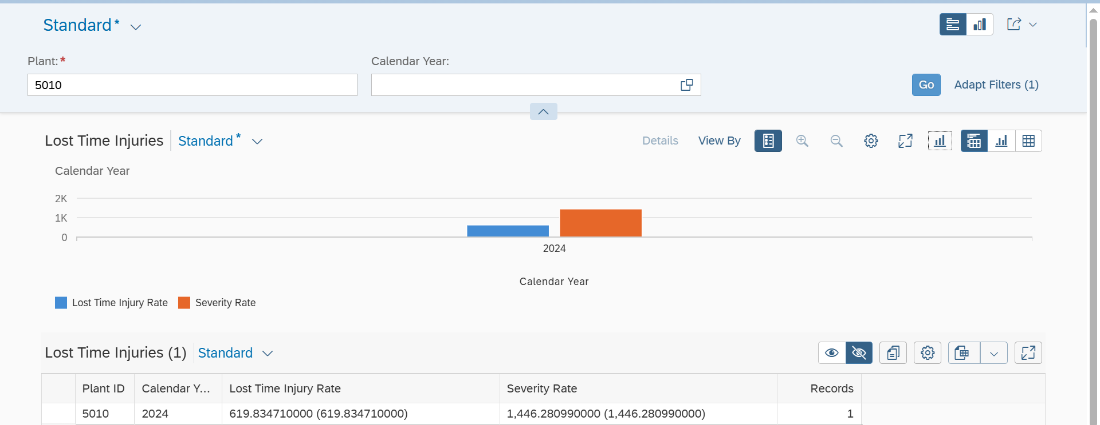

Logic:

- CDS: YC_LTI_RATE
This CDS view calculates Lost Time Injury Rate and Severity Rate for a plant on a yearly basis. It joins LTI records with man-hours data, aggregates working hours, and derives output using formulas.
- CDS: YC_LTI_RATE_CUBE
This CDS cube view is built on top of the LTI rate calculation view to enable analytical reporting. It exposes year and plant as dimensions and aggregates Lost Time Injury Rate and Severity Rate for consumption in analytical tools and dashboards.
- CDS: YC_LTI_RATE_MAIN
This main CDS analytical query view projects data from the LTI cube view and is exposed via OData for reporting. It defines query axes for year, records, and key safety KPIs, enabling end users to analyze Lost Time Injury and Severity rates interactively.
- Metadata:
Once the data is fetched from the CDS, a metadata is created to define the UI of the fiori app.
- Service Definition Exposure:
Once the metadata is defined for the CDS view entity elements, it is exposed through a service definition. This step makes the data accessible for external systems to consume.
- Service Binding and Maintenance:
The service definition is bound and maintained. This ensures that the service is available to the desired applications and users.
- Fiori Tile Creation and Role Assignment
A Fiori tile is created to display the data exposed by the service. Additionally, roles are assigned to ensure that only authorized users can access and view this tile.

Table Creation
N/A

Security /Authorization
N/A

User Exit
N/A

Transaction / Batch Job that will access enhancement
N/A

Anticipated performance Issues (if any)
N/A

Registration
N/A

Assumptions/ Notes

Unit Test Case
Screenshot for testing

- Report Screen:

N/A

- Fiori Screen:

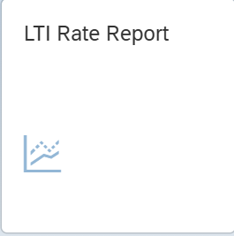



Technical Spec Original Sign Off:

Names and Signatures:

_____________ARNAV_______________________________ Date: ___09/12/2025________

____________________________________________________ Date: _____________

____________________________________________________ Date: _____________

____________________________________________________ Date: _____________

Modifications
< Description of Modification if any>
<Support document of the modification like screen shot of email received>

